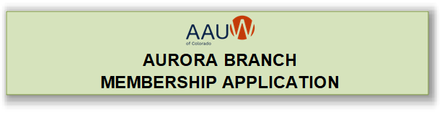

Name: __________________________________________________________
Address ________________________________________________________
Phone: _________________________;________________________________
(Home) (Cell)
Education (List degrees, date, college/university granting degree, major): __________
_________________________________________________________________
Degree Date College/University Major/Field of Study
_________________________________________________________________
Degree Date College/University Major/Field of Study
_________________________________________________________________
Degree Date College/University Major/Field of Study
Place of Employment (most recent; note if retired): _______________________
_________________________________________________________________
Email: ___________________________________________________________
Enclosed is my check for $102.00 for national, state and branch dues made payable to AAUW Aurora Co Branch for one full year. AAUW lifetime members only pay branch dues annually which total $20.00. Mail form and check to Treasurer, Theresa Campbell-Caron, 2192S Fairplay Street, Aurora, CO 80014.

